**Swine Weight Estimation Using Image Processing Techniques**

Problem:

* Weighing a pig is required to determine its growth, health and its market value.
* Weight manually is laborious, and it places a pig on stress.

Proposed Solution:

* Create a device to estimate a pig’s weight using only image analysis.

Needed to study:

* Weight estimation using image analysis using side and top view.

Measurement System:

* To estimate the pig’s weight, actual weight is needed.
* Proper image of the pig is required.
* The environment of where the pig will be captured should be properly arranged: the room where the pig is placed; the background color should be uniform; the lighting should be good and the distance of the camera from where the pig is observed should be fixed.
* For side view, the distance of the camera from the side of the pig should be fixed.
* For the top view, the height of the camera from the top of the pig should be fixed.

Scope and Delimitations:

* Pregnant pig is not handled.
* Only one pig can be analyzed at a time.

Image Processing (Overall):

* Image acquisition.
* Obtaining the region of interest (ROI) which is the pig.
* Segmentation of the ROI from the background.
* Filtering to remove noises and fill the whole segment.
* Contours.
* Feature extraction.
* Weight determination if the total area of the pig (number of pixels).

This is what you will see in your LCD in your Raspberry Pi, I just tested it in my computer, so I can easily get screenshots, but it will be the same in your Raspberry Pi. It has 8 buttons which has its own functionality. The buttons named SIDE VIEW PIXELS GRAPH and TOP VIEW PIXELS GRAPH are still empty and will be filled after the data gathering.

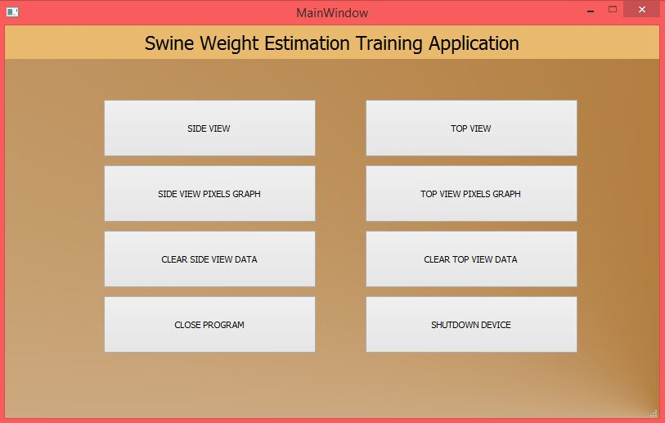

As mentioned previously it is your job to properly setup the environment where you will place the pig. Sample outputs are provided along this document.

NOTE that before testing you need to click CLEAR SIDE VIEW DATA and CLEAR TOP VIEW DATA if you have captured images that are not part of the data gathering because all the captured images along with its feature are saved as images and as a data in a text file. Once you started the data gathering, you should not play with the device anymore or you can save the pictures and text file to a flash drive. I’ll teach that personally.

To record the side image of the side view, click the side view button and you should see the camera view. You can use this view to calibrate the camera, click on the binary button to see if only the binary image of the pig is captured. For each pig samples, it is important to see the binary image first if it does contain only the pig (the white part of the binary image is just the pig). After that, enter the weight of the pig itself and its age then click capture button. All the image of the RGB, binary and contours are automatically saved along with the total area of the pig. Repeat this for all samples. See sample outputs below. (I just erased my face in the picture lol.)

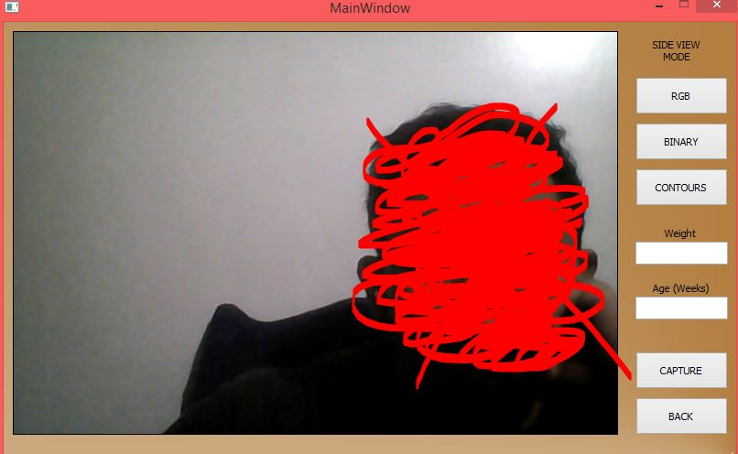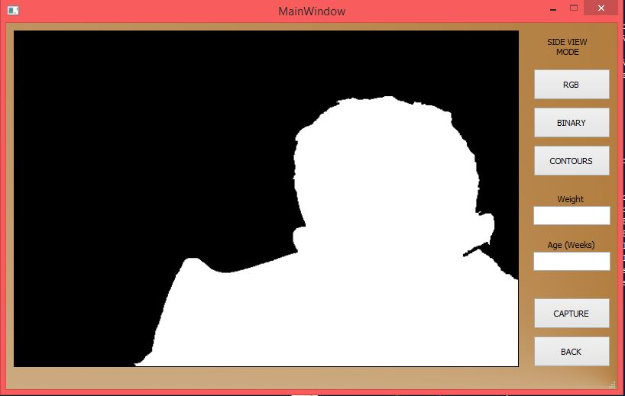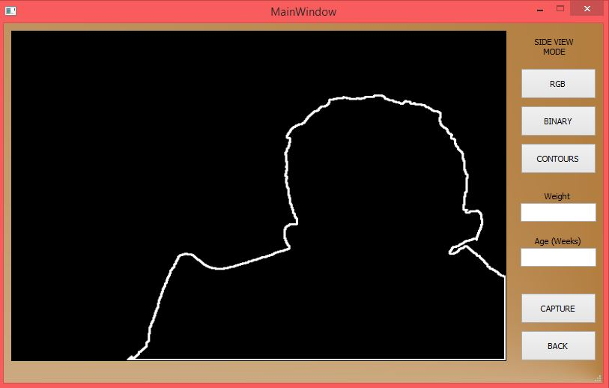

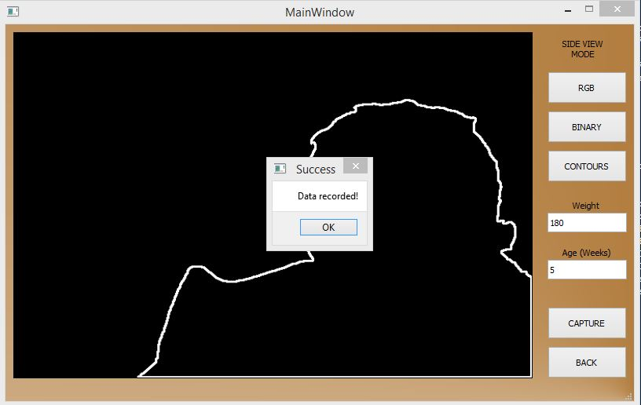

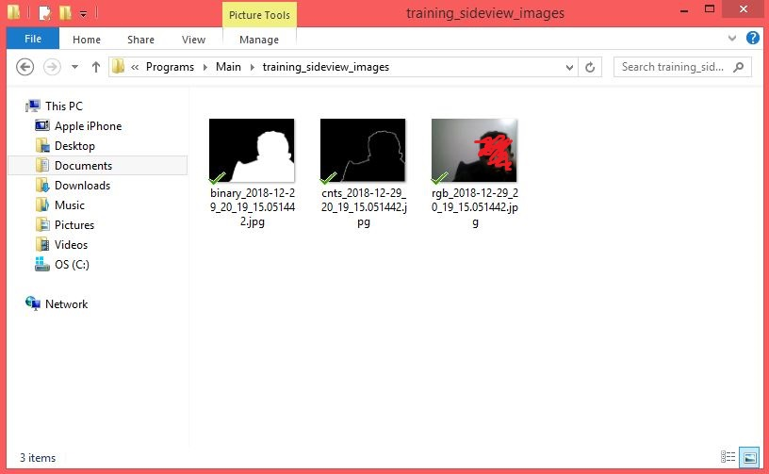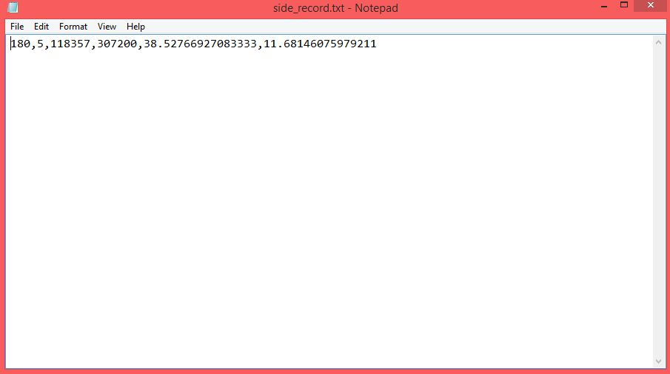

Press back button to go back to the main menu.

For the top view, do the same except that the device is now placed on top.

Again, note that once you start gathering data, do not play with the device by capturing random photos because all the data that is saved will be used to create your equation.

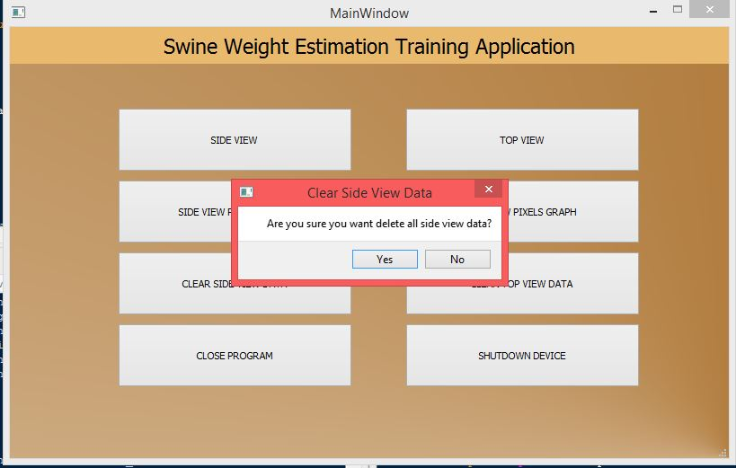

This is just a guide. I’ll demonstrate how to use it personally.

**Hardware Images**

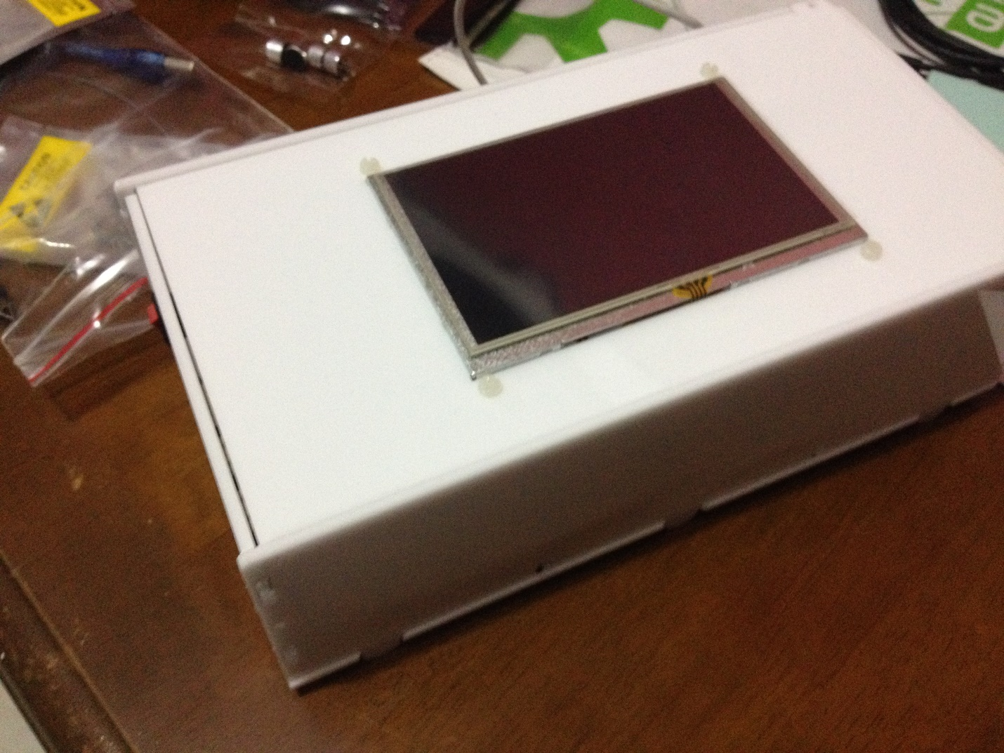

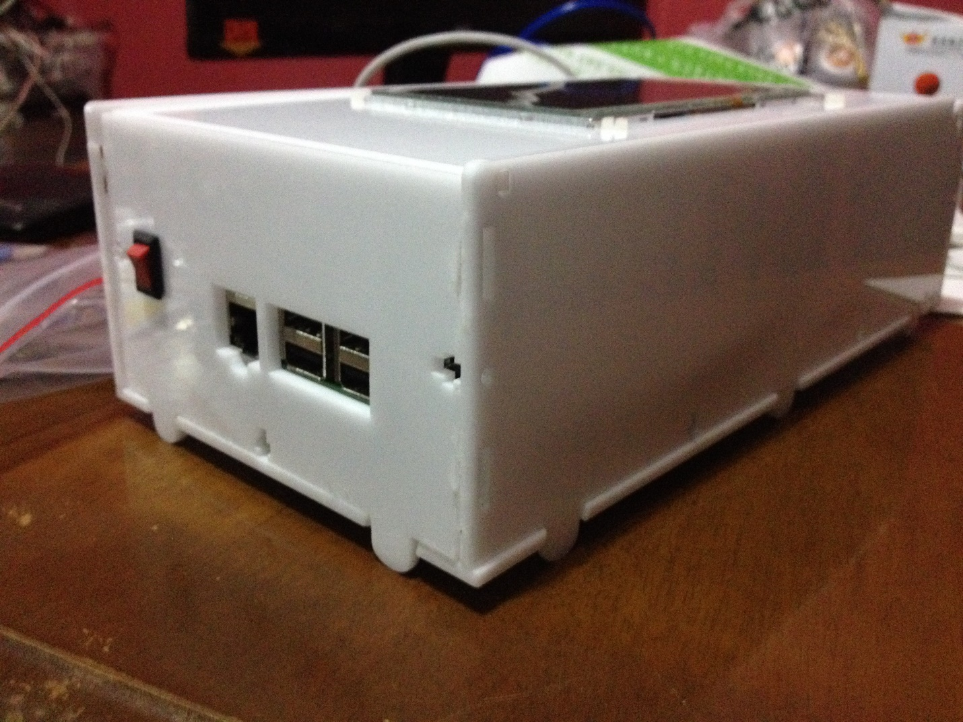

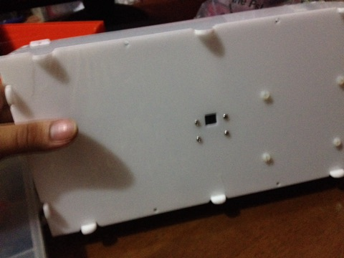

The camera is below the casing. The device is placed sideways when you are capturing side view images and it is placed as is in the photo above when you are capturing top view images.